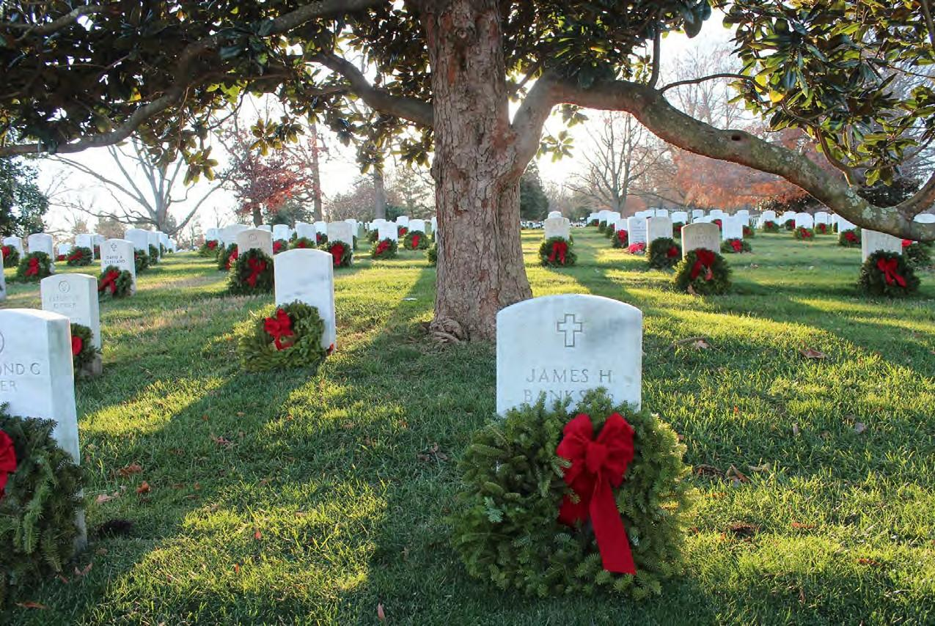

Join Us in Our Mission

Remember Honor Teach

December 12, 2026
National Wreaths Across America Day

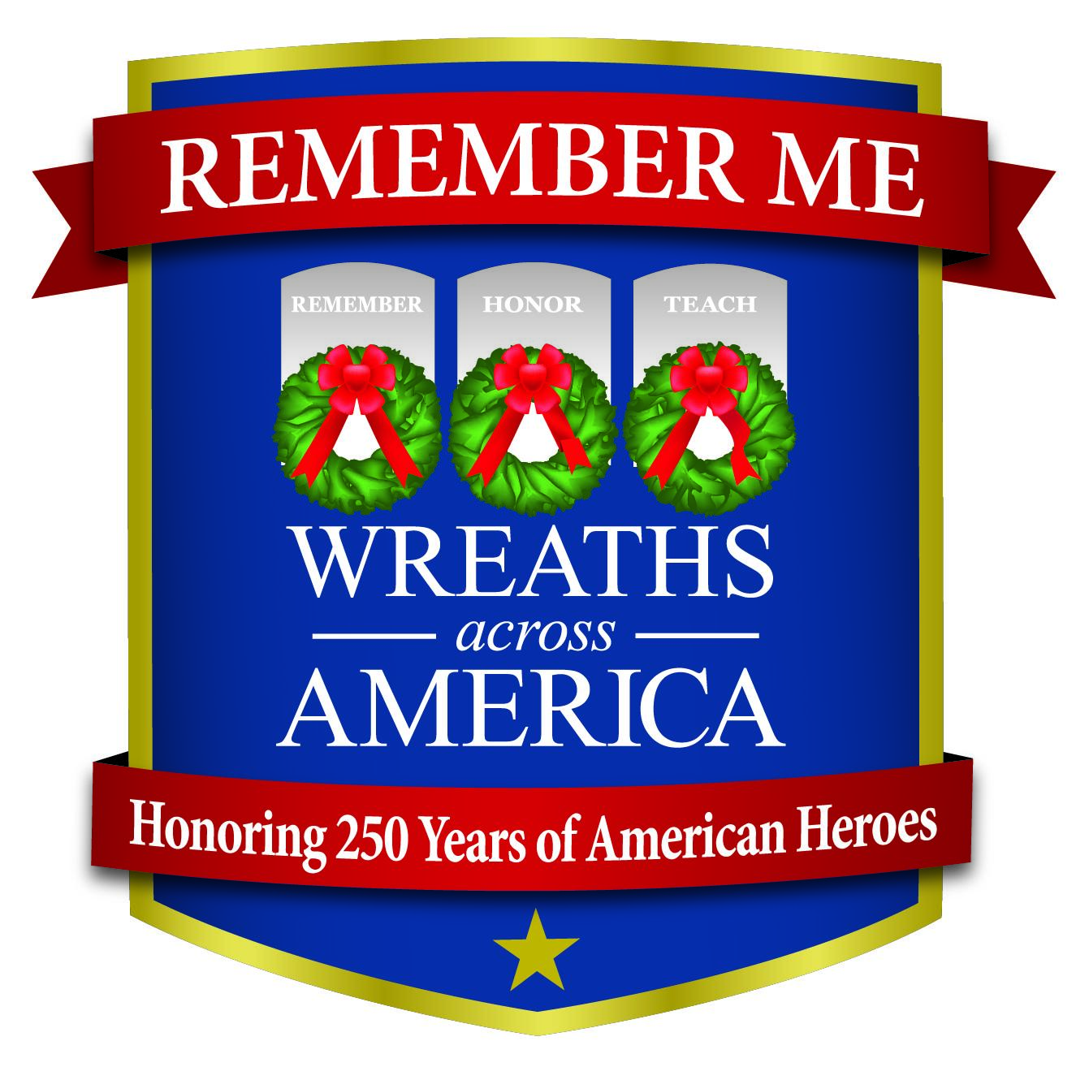

#RememberMe
Help Reserve Organization of America honor local heroes!

Sponsor a wreath today to be placed on a veteran’s grave this December at
Sandhills State Veterans Cemetery

Scan the QR code to make a donation online or visit www.wreathsacrossamerica.org/NC0369P


