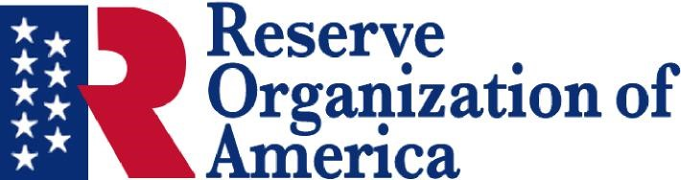
www.ncroa.org

North Carolina Department
State Convention
11 July 2026
https://www.ncroa.org/events/index.php?id=1772385028

American Legion Post 1
Raleigh, NC 27615
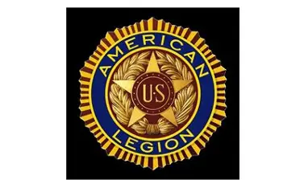

Agenda

Call to Order COL Ihor “Iggi” Husar, USA, President

Opening Prayer CDR John Leonard, USCG

Pledge of Allegiance COL Husar

Roll Call LTC Mike Moose, USA, Secretary

Acknowledgements LTC Mike Moose

Candidates for Office COL Husar

Election of Officers All Department Members

Election Results COL Husar

Delegates to National Convention LTC Mike Moose

Department Resolutions CDR John Leonard

2026 College ROTC Events LTC Mike Moose

Lunch Box Lunch

Remarks by Guests Speaker Introductions by COL Husar

ROA Updates LTC Mike Moose

Guest Speaker s MG Peggy Wilmoth
President Elect-ROA

Closing Remarks COL Husar

Announcements LTC Tom Froneberger
Social Time

